TIME VAULT

You are on the “Archives Page.” This one page provides access to a world of information:

Time vault: Original newspapers, articles and documents, illustrations, drawings, photographs, maps, charts and an historical dictionary.

Rare Book Room: Original books, in their entirety and original form, are just a click away.

Video Library: Original videos, created from sources contained within our archives, bring the past alive!

Lessons: Here, teachers can shine, with a facility to create exciting and stimulating lessons, using original source material.

Games: A fun and educational way to learn a subject and prepare for an exam.

My Favorites: Have you ever spent hours researching a subject, saved your results and forgot where you saved them? This facility saves them for you!

MENU BAR

By default the archives page opens in the Time Vault. Just below the highlighted Time Vault tab you will also see highlighted “Articles in Timeline”

Select an Era
Select a year. Note that the small box icon provides a thumbnail image of the article; the round icon provides more information, such as bibliographical data, and text version in English and Spanish.
More information Icon Thumbnail of image

Article information box provides:
An icon for printing the text version; an icon to view original item full size, and if related to a newspaper, a newspaper icon to view the original newspaper in its entirety.

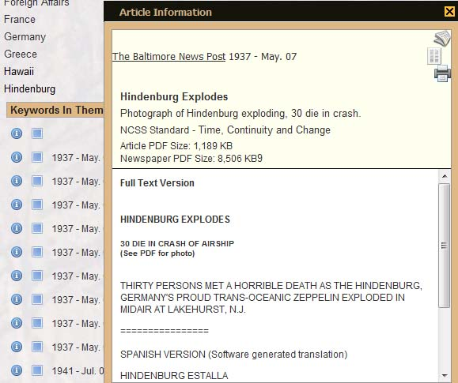
View newspaper
More Information View Article
Print Text

Text in English and Spanish

For a thumbnail image,
click the small square icon

Next to the Timeline tab is the “Articles Grouped in Themes” tab. Clicking it and selecting an Era displays themes relating to that era. Selecting a theme displays items relating to the theme.
Once again, you will see two icons, as in the timeline. The round icon is for “More Information,” and the small square icon is for a “Thumbnail of Image.”

“Themes”

Theme = “Edison, Thomas Alva”

“Articles relating to Themes”

Articles

Search (Keywords and Dictionary)

“Search for Article/Documents” provides a keyword search for the Time Vault and Historical Dictionary. Here one can not only see the definition of a word but how it is used in original material.

Try the Keyword Tyranny, for example. The list builds as you type:

Definition
Original Item:
This concludes your tour of the Time Vault.

