PUBLIC LIBRARY ACCESS AND LOGIN
OVERVIEW

All patrons have at-home or library access. Some libraries may have our logo on their home page and some provide access in a list of vendors. Either way, entering your library card number and your state puts you in Journey’s archives.
Here is an example

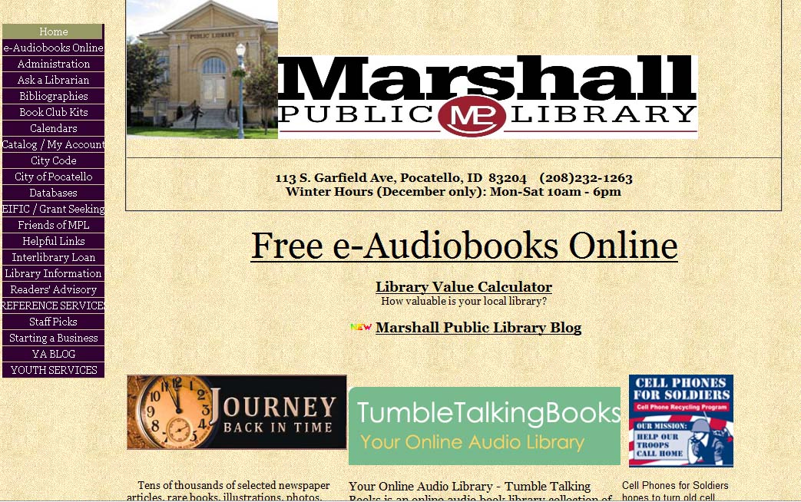

Click the Logo

Enter your state and library card number.
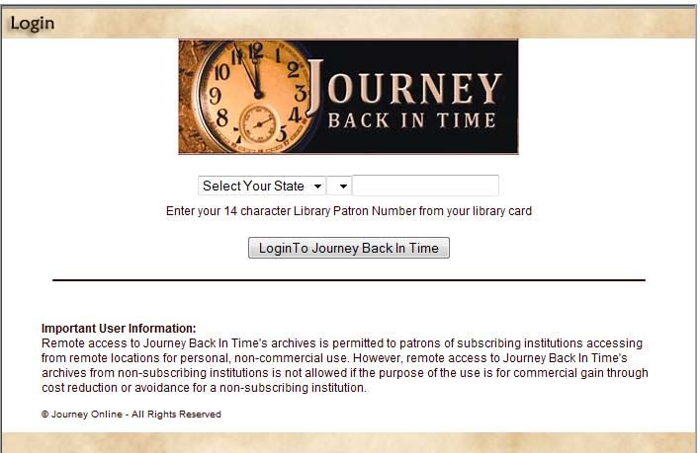

You are directed to the setup page. Enter your name to save your research, but if you are at a public terminal, do not check the box to “Remember Me”
Your research will be saved for availability next time you login.

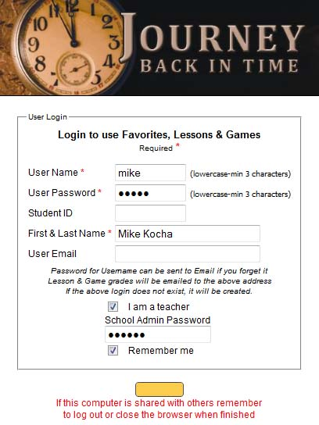
Do NOT check this box, if you are at a public terminal.
Click “Continue”

You are now on the archives page
