Frequently Asked Questions

- Most inquires are for the following:
Question: I get a page that says:
“Login Failed”

Answer:
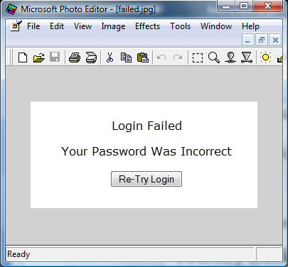

We remember your ID and password, even if you enter it incorrectly. To correct this issue, you must either clear your cookies or go to this page

http://journeybackintime.com/access/jbit.html

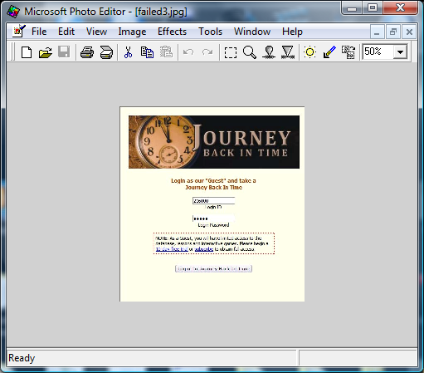
Once on this page, press the “Enter” key or “Esc” 3 times; next, refresh the page, or close the browser and restart. You will now see Login ID as “Guest” Re-enter your ID and Password (using CAPITAL LETTERS). This should correct the problem. You should not have to enter these login items again on this computer. If you are still having problems, please email mike@journeybackintime.com (and include your phone number).

- Question: The screen seems to freeze up, and I cannot click on anything; what should I do?
Answer: our program is much like a software application. If your screen freezes, close the application and begin again.

